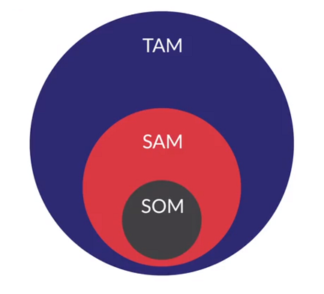

**TAM (Total available market)** – which is the total market demand of a product or a service

**SAM (Serviceable available market)** – is the fraction of TAM targeted by you within your geographical reach

**SOM (Serviceable obtainable market)** - is the market you can capture.

**Market Sizing**

**Top down approach**

Broad to target

**Bottom up approach**

Target to broad

<https://www.indiastat.com/> is the website for stats of consumers.

Below is an example to estimate the market size of a product

**Suggested Answer**

For the AC example from the video:

**FORMULA:**

Total demand = [(Estimated # of ACs) / (Average Lifespan of an AC)] + [(Estimated # of ACs )*(Growth Rate)].

**COMPONENTS:**

Total population, % urban/rural households, growth rate, % upper class, % middle class, average